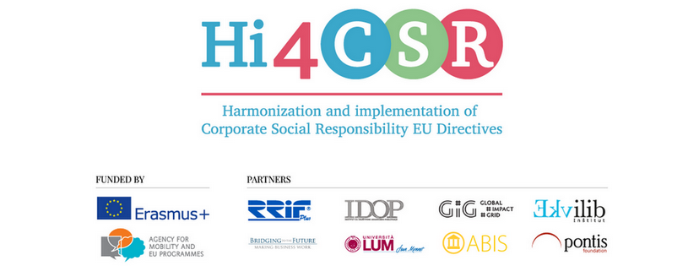
31th of July 2017
PRESS RELEASE
Hi4CSR project invites you to find out more about CSR and sustainability topics

Erasmus+ project under the name Harmonization and implementation of EU CSR Directives – Hi4CSR began in October 2016 and will last until April of 2018. It is a transeuropean project established by eight European organizations renowned in the field of CSR - RRiF-plus Ltd. (Croatia), The Croatian Institute for CSR – IDOP (Croatia), Abis – The Academy of Business in Society (Belgium), Ekvilib Institute (Slovenia), Global Impact Grid (Germany), LUM University (Italy), Pontis Foundation (Slovakia) and Bridging to the Future (United Kingdom).
Main objectives of the project are adult education, exchange of examples of good practices between project partners regarding harmonization and implementation of EU Directives as well as development of the first CSR Guide which will cover topics ranging from non-financial reporting, eco labelling, water framework, food donations and the employment of people with disabilities, to innovation and waste management.
On July 5th 2017, second Transnational project meeting (TPM) within the Hi4CSR project took place in London, United Kingdom, with an aim to monitor project’s progress, discuss partners’ responsibilities and plan future activities.
During July, project partners have also written articles about a number of topics, such as best practices in sustainable waste management and food donation, eco- and CSR-labelling as well as risks associated with two specific waste streams: plastic- & e-waste, all of which you can find below:
- The second TPM took place in London, United Kingdom!
- Facilitating food donation: The Good Samaritan Law
- Prelog: Best practice in sustainable waste management in Croatia
- The end of the sticky label
- “CSR Made in Germany” Label
- E-waste: the fastest-growing waste stream in the EU
- Our addiction to plastic is creating an environmental crisis

You can find additional information about the project on the www.hi4csr.com website, write to the consortium at info@hi4csr.com or connect through our social media pages: Facebook, Twitter, LinkedIn and YouTube channel.

