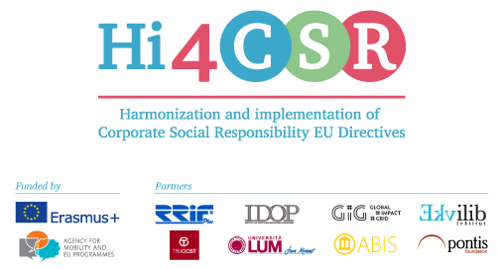
Erasmus+: Harmonization and Implementation of EU CSR Directives – Hi4CSR
April 2017

PRESS RELEASE
Hi4CSR consortium invites you to find out more about five CSR topics and the implementation of related EU Directives
Erasmus+ project under the name Harmonization and implementation of EU CSR Directives – Hi4CSR began in October 2016 and will last until April of 2018. It is a transeuropean project established by several European organizations renowned in the field of CSR - RRiF-plus d.o.o. (Croatia), The Croatian Institute for CSR – IDOP (Croatia), Abis – The Academy of Business in Society (Belgium), Ekvilib Institute (Slovenia), Global Impact Grid (Germany), LUM University (Italy) and Pontis Foundation (Slovakia).
Main objectives of the project are adult education, exchange of examples of good practice between project partners regarding harmonization and implementation of EU Directives as well as development of the first CSR Guide which will cover topics ranging from non-financial reporting, eco labeling, water framework, food donations and the employment of people with disabilities to innovation and waste management.
All the topics that the consortium will present and discuss are in accordance with the Europe 2020 Strategy in promoting smart, sustainable and inclusive growth and developing Corporate Social Responsibility in the EU.
During April, Hi4CSR consortium was preparing the next learning activity which will take place from 15th to 19th of May in Berlin, as well as researching project topics and creating new content, some of which can be found on our blog:

- Millennial generation drives up demand for CSR and positive impact
- Sustainability Reporting can be fun!
- New EU electronic certification system will improve food traceability
- New developments regarding the implementation of the Waste Management Plan in Croatia
- How the ABIS member Solvay supports the UN Sustainable Development Goals
You can find additional information about the project on the www.hi4csr.com website, write to the consortium at info@hi4csr.com or connect through our social media pages: Facebook, Twitter and LinkedIn.

