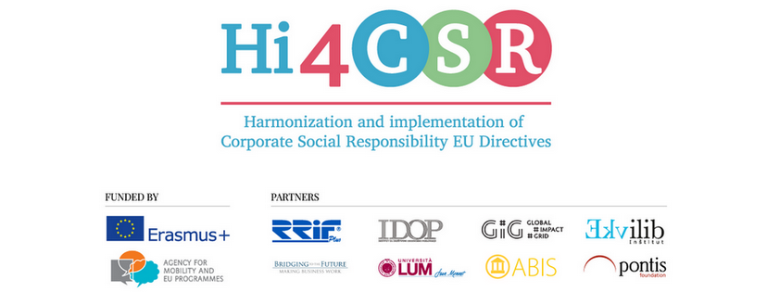
March 23rd 2018
PRESS RELEASE
Final activity in the Hi4CSR project!
Erasmus+ project Hi4CSR (Harmonization and implementation of EU CSR Directives) started in October of 2016 and will end next month, in April of 2018. It is a transeuropean project established by eight European organizations renowned in the field of CSR - RRiF-plus Ltd. (Croatia), The Croatian Institute for CSR – IDOP (Croatia), Abis – The Academy of Business in Society (Belgium), Ekvilib Institute (Slovenia), Global Impact Grid (Germany), LUM University (Italy), Pontis Foundation (Slovakia) and Bridging to the Future (United Kingdom).
Main objectives of the project were adult education, exchange of good practices and development of the first CSR Guide covering topics such as non-financial reporting, eco labelling, water legislation, circular economy, food donations and the employment of people with disabilities.
In March, partners published new articles on the Hi4CSR blog for the last time, exploring what is new in the world of corporate social responsibility and the impact of CSR policies, strategies and practices. New articles can be found below:
- What is new in the world of corporate social responsibility?
- Barilla aims for sustainability by entering the bio-market
- Global CSR strategies: Volkswagen
- The impact of global CSR strategies
- GDPR is coming: are we ready?
- What is the future of diesel?
- Sustainable Development Goals 2017 – the performance of Slovakia
- EU plan towards Circular Economy: the first-ever Europe-wide strategy on plastic
- Circular economy: the end of landfilling in the EU?
- Coffee Cups, An Unknown Quantity
- Maribor, European Capital of Social Economy 2018
- Italy becomes smart!
The final meeting in the project will take place on 26th of March 2018 in Zagreb, when the results of the project will be presented and the published CSR Guides will be handed out to project partners.
You can find additional information about the project on the www.hi4csr.com website, write to the
consortium at info@hi4csr.com or connect through our social media pages: Facebook, Twitter, LinkedIn and YouTube channel.

