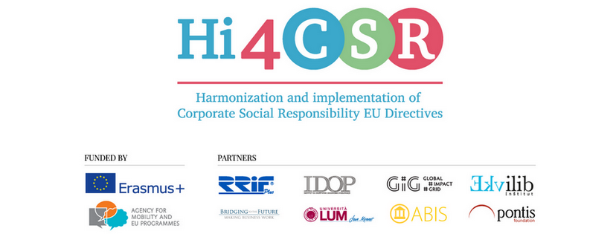
February 23rd 2018
PRESS RELEASE
Find out more about corporate volunteering
Erasmus+ project under the name Hi4CSR (Harmonization and implementation of EU CSR Directives) started in October of 2016 and will end in April of 2018. It is a transeuropean project established by eight European organizations renowned in the field of CSR - RRiF-plus Ltd. (Croatia), The Croatian Institute for CSR – IDOP (Croatia), Abis – The Academy of Business in Society (Belgium), Ekvilib Institute (Slovenia), Global Impact Grid (Germany), LUM University (Italy), Pontis Foundation (Slovakia) and Bridging to the Future (United Kingdom).
Main objectives of the project are adult education, exchange of good practices and development of the first CSR Guide covering topics of non-financial reporting, eco labelling, water legislation, circular economy, food donations and the employment of people with disabilities.
In February, partners explored project topics and published new articles on the Hi4CSR blog. This month in particular focused on using business as a force for good, whether through corporate volunteering, becoming a B Corp or starting a social enterprise with an aim to tackle one of the most pressing social issues – food waste. New articles can be found below:
- Corporate Volunteering: Helping other helps your company too
- B planet's green sealing wax
- Refill Campaign: Tackling the source of plastic waste
- Toast Ale: Best thing since sliced bread
- Food waste: France is the most sustainable country
- Germany is one of the most sustainable industrial countries
- Monitoring the progress towards circular economy
You can find additional information about the project on the www.hi4csr.com website, write to the consortium at info@hi4csr.com or connect through our social media pages: Facebook, Twitter, LinkedIn and YouTube channel.

