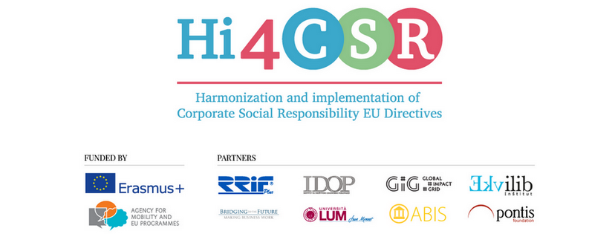
December 21st 2017
PRESS RELEASE
Find out more about the zero-waste movement!

Erasmus+ project under the name Hi4CSR (Harmonization and implementation of EU CSR Directives) started in October 2016 and will last until April of 2018. It is a transeuropean project established by eight European organizations renowned in the field of CSR - RRiF-plus Ltd. (Croatia), The Croatian Institute for CSR – IDOP (Croatia), Abis – The Academy of Business in Society (Belgium), Ekvilib Institute (Slovenia), Global Impact Grid (Germany), LUM University (Italy), Pontis Foundation (Slovakia) and Bridging to the Future (United Kingdom).
Main objectives of the project are adult education, exchange of good practices between project partners regarding harmonization and implementation of EU Directives as well as development of the first CSR Guide which will cover topics such as non-financial reporting, eco labelling, water framework directive, circular economy, food donations and the employment of people with disabilities.
During December, Hi4CSR consortium was researching project topics and publishing new articles on corporate social responsibility and sustainability. This month in particular revolved around circular economy, with articles exploring the rise of the zero waste movement and the importance of sustainable use of resources such as water and secondary raw materials, while others explain the role of ecodesign and ecolabelling in ensuring sustainable production and consumption patterns. These and other articles can be found below:
- Špeceraj: first zero-waste store in Croatia
- What is good for you is it good for the Earth too?
- The importance of ecodesign in circular economy
- Waste as a business opportunity
- EU Ecolabel: where does Italy stand?
- CSR news and magazine
- The Water Crisis, an SME response
You can find additional information about the project on the www.hi4csr.com website, write to the consortium at info@hi4csr.com or connect through our social media pages: Facebook, Twitter, LinkedIn and YouTube channel

