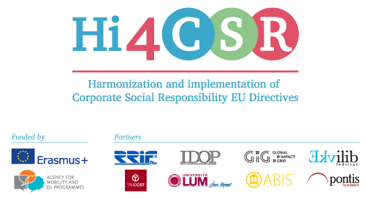
Erasmus+: Harmonization and Implementation of EU CSR Directives – Hi4CSR
March 8th, 2017
PRESS RELEASE
Download educative materials on five CSR topics!
From January 30th until February 3rd 2017 in RRiF College for Financial Management in Zagreb, the first learning activity within Hi4CSR finally took place! Participants of the learning activity were members of the consortium consisted of eight renowned European organizations in the field of CSR: RRiF-plus d.o.o. (coordinator, Croatia), The Croatian Institute for CSR (Croatia), Abis – The Academy of Business in Society (Belgium), Ekvilib Inštitut (Slovenia), Global Impact Grid (Germany), LUM University (Italy), Pontis Foundation (Slovakia) and Trucost (United Kingdom).

Considering the fact that the primary goal of the project is adult education and the exchange of best practices between project partners when it comes to the harmonization and implementation of European directives in the area of corporate social responsibility to national legal frameworks, a five-day activity was designed in a way that every day was dedicated to a specific area.

Nurturing the principle of transparency and the dissemination of gathered knowledge during the exchange of good practices, Erasmus+ strategic partnerships ensure complete availability of all educational materials.

The purpose of this decision is to provide online access of the project’s educational materials in order to assure equal opportunities for learning about EU CSR Directives, as well as to assist companies and individuals across EU when it comes to understanding and implementing these topics.

You can find the educational materials here:
- Directive on Obligatory Non-Financial Reporting
- Directive regarding the subject of Eco labelling
- Directive on Employment of Disabled Persons
- EU General Food Law and Food Hygiene Legislation
- Stimulating the processing of used materials.
FUTURE ACTIVITIES
The following learning activity will take place in Berlin, from May 15th to May 19th 2017.
If you have any questions for the consortium, feel free to write to us at info@hi4csr.com.

You can find additional information about the project on the website www.hi4csr.com, write to the consortium at info@hi4csr.com, or connect through social media pages: Facebook, Twitter and LinkedIn.

