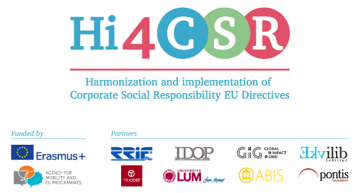
Erasmus+: Harmonization and Implementation of EU CSR Directives – Hi4CSR
November 16th, 2016

PRESS RELEASE
The transeuropean project between eight project partner countries will examine the success of the EU Directives in corporate social responsibility

Within the Erasmus+ project under the name Harmonization and Implementation of EU CSR Directives – Hi4CSR, ABIS will be a project partner from Belgium and will participate in the first EU project oriented at the examination of the succes of the EU Directives in the area of corporate social responsibility (CSR).
The project officially began in October 2016 and will last until April of 2018. Main objective of the project is adult education and the exchange of examples of good practices between project partners when it comes to harmonization and implementation of EU Directives in CSR. The coordinator of the project is a Croatian leading company for accounting and finances, RRiF-plus d.o.o., with the following partners: Abis – The Academy of Business in Society (Belgium), Ekvilib Institute (Slovenia), Global Impact Grid (Germany), Institut za drustveno odgovorno poslovanje (Croatia), LUM University (Italy), Pontis Foundation (Slovakia) and Trucost (United Kingdom).
Through seven main project activities, three one-day meetings and four five-day learning activities, project partneres will work on the development of the first CSR Guide that will in a clear and systematic way present the current status when it comes to the issues of EU CSR Directives, regarding topics such as waste management, food donations, eco labeling, non-financial reporting, the employment of people with disabilities, innovation, and the water framework. The project also aims to contribute to the development of sustainable policies and the strategy Europe 2020 through equal involvment and education of European enterprises, universities, non-profit organizations and NGO's.
The project has been opened with a one day meeting in Ljubljana, Slovenia, while the first five-day learning activity will take place in Zagreb, Croatia, in January of 2017.
You can find additional information about the project on the website www.hi4csr.com, as well as on social media pages: Facebook, Twitter and LinkedIn.
Picture 1: Working atmosphere at the first transnational meeting in Ekvilib Institute, Ljubljana
