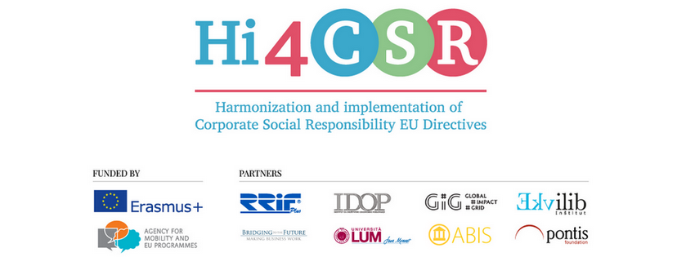
November 2017
PRESS RELEASE
Fourth learning activity took place in Bratislava, Slovakia!
Fourth Hi4CSR Learning Activity took place from 13th to 17th of November 2017 in Bratislava. The event was hosted by Pontis Foundation and its participants were members of seven renowned European organizations in the field of CSR: RRiF-plus Ltd. (coordinator, Croatia), The Croatian Institute for CSR (Croatia), Ekvilib Institute (Slovenia), Global Impact Grid (Germany), LUM University (Italy), Pontis Foundation (Slovakia) and Bridging to the Future (United Kingdom).
Main goals of the project are adult education, exchange of good practice examples between project partners and dissemination of accumulated knowledge. Since project deals with harmonization and implementation of EU CSR legislation into national legal frameworks, the learning activity was organized in a way to cover all six project topics.
On the first day, participants worked on two project topics: Stimulating the processing of used materials with the accompanying Directive 2006/112/EC and Eco-labels with the related Regulation (EU) No 1169/2011.
On the second day, the participants attended CEE CSR summit 2017, the largest and oldest conference for corporate social responsibility in Central and Eastern Europe. During the conference, organized by Pontis Foundation, project partners had the opportunity to learn from leading experts in the field of CSR and sustainability, such as Lord Michael Hastings from KPMG International, who spoke about Sustainable Development Goals as challenges and opportunities for future business. Karina Govindji from Vodafone spoke about diversity as a key to success of every company, and Michal Kissa from Pontis Foundation presented a survey on public perception of corporate social responsibility and responsible entrepreneurship in Slovakia. Aaron Sherinian, one of the founders of the #GivingTuesday initiative, gave a speech about the new era of philanthropy in a globalized and increasingly interconnected world. Miguel Coleta from Philip Morris International showed how tobacco company can contribute to public health.
Third day of the learning activity was dedicated to social innovation and capacity building of civil society organizations. Radoslav Mizera from Solved spoke about the necessity of creating cleantech solutions, sustainable energy, smart mobility systems and smart cities.
Zuzana Matúšová from Habitat for Humanity presented different fundraising strategies and ways of collaboration between the business sector and civil society, while Anna Podlesná, Martina Kolesarová, Pavel Hrica and Jakub Šimek from Pontis Foundation presented their organization and its projects, and shared their experiences in corporate philanthropy, corporate volunteering, effective altruism and social entrepreneurship.
On the fourth day, partners worked on the topics of Non-Financial reporting, the related Directive EU2014/95 and its implementation into national legal frameworks, as well as the EU Water Framework with the Directive 2000/60/EC. Last day was dedicated to two topics: employment of persons with disabilities with the related Directive 2000/78/EC and food donation in the legislative framework of the Directive 2006/112/EC.

During the learning activity, project partners collaborated on the development of the CSR Guide, which will be the first comparative study of its kind to cover six topics from the field of corporate social responsibility and sustainability, and will present, in a clear and systematic way, implementation and harmonization of related EU legislation, as well as best practice examples from different member states.

You can find additional information about the project on the www.hi4csr.com website, write to the consortium at info@hi4csr.com or connect through our social media pages: Facebook, Twitter, LinkedIn and YouTube channel.

