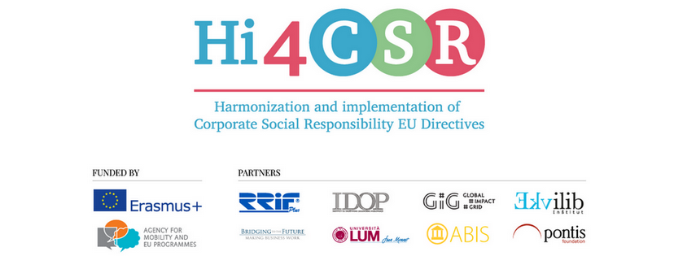
October 30th 2017
PRESS RELEASE
New trends in CSR and sustainability reporting

Erasmus+ project under the name Hi4CSR (Harmonization and implementation of EU CSR Directives) started in October 2016 and will last until April of 2018. It is a transeuropean project established by eight European organizations renowned in the field of CSR - RRiF-plus Ltd. (Croatia), The Croatian Institute for CSR – IDOP (Croatia), Abis – The Academy of Business in Society (Belgium), Ekvilib Institute (Slovenia), Global Impact Grid (Germany), LUM University (Italy), Pontis Foundation (Slovakia) and Bridging to the Future (United Kingdom).
Main objectives of the project are adult education, exchange of good practices between project partners regarding harmonization and implementation of EU Directives as well as development of the first CSR Guide which will cover topics such as non-financial reporting, eco labelling, water framework directive, circular economy, food donations and the employment of people with disabilities.
During October, Hi4CSR consortium was preparing for the fourth Learning Activity which will take place from 13th to 17th November in Bratislava during which partners will also attend the CEE CSR Summit, largest and oldest CSR event in Central and Eastern Europe.
Project partners also continued to research project topics and publish new articles on CSR and sustainability, in particular about new trends in CSR- and sustainability reporting, CSR as a benefit for the economy and its meaning for particular organization, with Tesla Inc. as an example of a sustainable and responsible company. When it comes to the topic of circular economy, articles have explored the importance of waste hierarchy, life cycle thinking approach in waste management and food recycling. Water-related topics dealt with the implementation of the Water Framework Directive in Italy and Commission’s report on improving bathing water quality in Europe. These and other articles can be found below:
- What is paramount in reporting in 2017
- What does CSR mean for your organisation? Putting theory into practice
- Inspiration from beyond the ocean: Elon Musk reminds us of the meaning of CSR
- CSR: a benefit for the economy
- National CSR forum in Germany

- The importance of waste hierarchy in circular economy
- Life cycle thinking in sustainable waste management
- Food Recycling… Am I bothered?
- The importance of water: Italy is making an effort
- Bathing water quality standards in Europe better than ever before
- EU Ecolabel celebrates 25 years of life!
- European Union launches the Social Challenges Innovation Platform

You can find additional information about the project on the www.hi4csr.com website, write to the consortium at info@hi4csr.com or connect through our social media pages: Facebook, Twitter, LinkedIn and YouTube channel.

