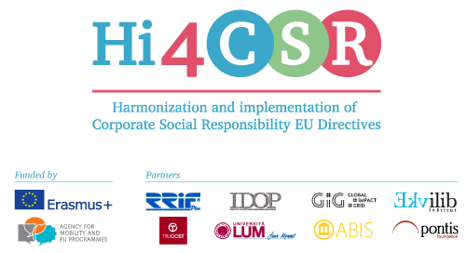
Erasmus+: Harmonization and Implementation of EU CSR Directives – Hi4CSR
January 23rd, 2017
PRESS RELEASE
Hi4CSR consortium invites you to play the CSR Game and find out your CSR index!
Erasmus+ project under the name Harmonization and implementation of EU CSR Directives – Hi4CSR began in October 2016 and will last until April of 2018. It is a transeuropean project established by the eight renowned European organizations in the field of CSR - RRiF-plus d.o.o. (Croatia), The Croatian Institute for CSR – IDOP (Croatia), Abis – The Academy of Business in Society (Belgium), Ekvilib Institute (Slovenia), Global Impact Grid (Germany), LUM University (Italy), Pontis Foundation (Slovakia) and Trucost (UK). Main objective of the project is adult education and the exchange of examples of good practices between project partners when it comes to harmonization and implementation of EU Directives.
Through seven main project activities, three one-day meetings and four five-day learning activities, project partneres will work on the development of the first CSR Guide that will in a clear and systematic way present the current status when it comes to the issues of EU CSR Directives, regarding topics such as non-financial reporting, eco labeling, food donations, the employment of people with disabilities, innovation, the water framework and waste management.
All the topics that the consortium will present and discuss are in line with the strategy Europe 2020, they are focused on the issues of the development of CSR in the EU, as well as sharing the best practices when it comes to the EU CSR Directives.
In order to bring close mentioned topics to the general public, enterprises, decision makers and young experts, Hi4CSR consortium created a CSR Game that gives the opportunity to calculate organization's CSR index! Through six basic questions you can find out whether your organization just began taking the CSR road or whether you live and breath core CSR values. You can find the game here: www.hi4csr.com/en/csr-game-calculate-your-csr-index!/.
The first learning activity within Hi4CSR will take place in Zagreb, Croatia from January 30th to February 3rd. More ''behind the scenes'' information you can find on the projects' blog: http://www.hi4csr.com/en/blog/.
You can find additional information about the project on the website www.hi4csr.com, write to the consortium at info@hi4csr.com, or connect through social media pages: Facebook, Twitter and LinkedIn.

