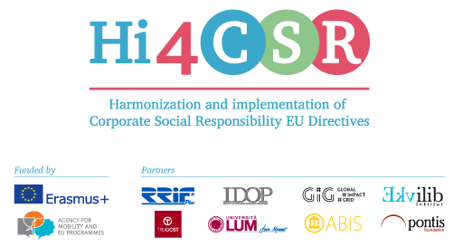
Erasmus+: Harmonization and Implementation of EU CSR Directives – Hi4CSR
December 14th, 2016
PRESS RELEASE
Hi4CSR blog: Erasmus+ on-line platform that gathers important and useful information about EU CSR Directives
Erasmus+ project under the name Harmonization and implementation of EU CSR Directives – Hi4CSR began in October 2016 and will last until April of 2018. It is a transeuropean project established by the eight renowned European organizations in the field of CSR - RRiF-plus d.o.o. (Croatia), The Croatian Institute for CSR – IDOP (Croatia), Abis – The Academy of Business in Society (Belgium), Ekvilib Institute (Slovenia), Global Impact Grid (Germany), LUM University (Italy), Pontis Foundation (Slovakia) and Trucost (United Kingdom). Main objective of the project is adult education and the exchange of examples of good practices between project partners when it comes to harmonization and implementation of EU Directives.
Through seven main project activities, three one-day meetings and four five-day learning activities, project partneres will work on the development of the first CSR Guide that will in a clear and systematic way present the current status when it comes to the issues of EU CSR Directives, regarding topics such as non-financial reporting, eco labeling, food donations, the employment of people with disabilities, innovation, the water framework and waste management.
In order to bring close mentioned topics to the general public, enterprises, decision makers and young experts, Hi4CSR consortium established an online platform that will in a form of a blog on a monthly basis discuss and argue many relevant topics. Since every partner chose a specific area that they wish to research during the project, as well as share their good practices with other partners, blog will be an opportunity to in a somewhat less informal way present mentioned topics and all the social and economic aspects around them.
At the moment, one can find articles such as:
- EU Non-financial Directive: What is it going to be like in Italy?,
- The culture of food donations in Croatia,
- CSR and employment of persons with disabilities,
- Stimulating the processing of used materials,
- Dozens of Companies in Slovakia Are Required to Disclose Information about Their Corporate Responsibility,
- European Pact for Youth: Business-education partnerships to boost youth employment and inclusion in Europe
and many more.
All the topics that the consortium will present and discuss are in line with the strategy Europe 2020, they are focused on the issues of the development of CSR in the EU, as well as sharing the best practices when it comes to the EU CSR Directives.
You can find additional information about the project on the website www.hi4csr.com, write to the consortium at info@hi4csr.com, or connect through social media pages: Facebook, Twitter and LinkedIn.

